Enhance your Résumé Skills with VMock

- Please provide a screen shot from VMock of your résumé and feedback. See example below. Ensure the screenshot shows your name.
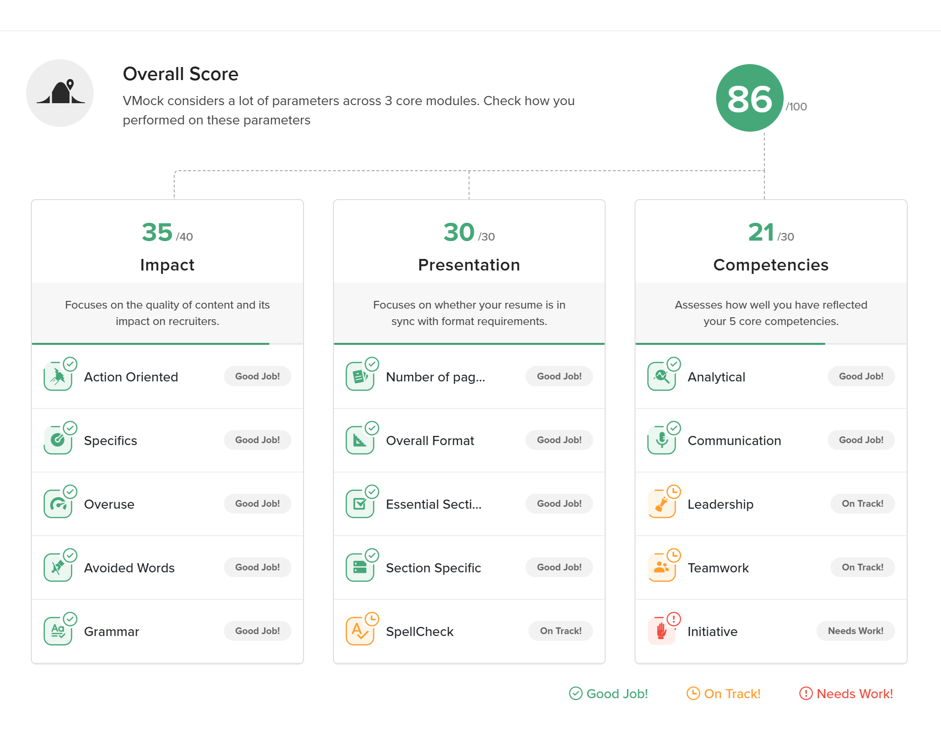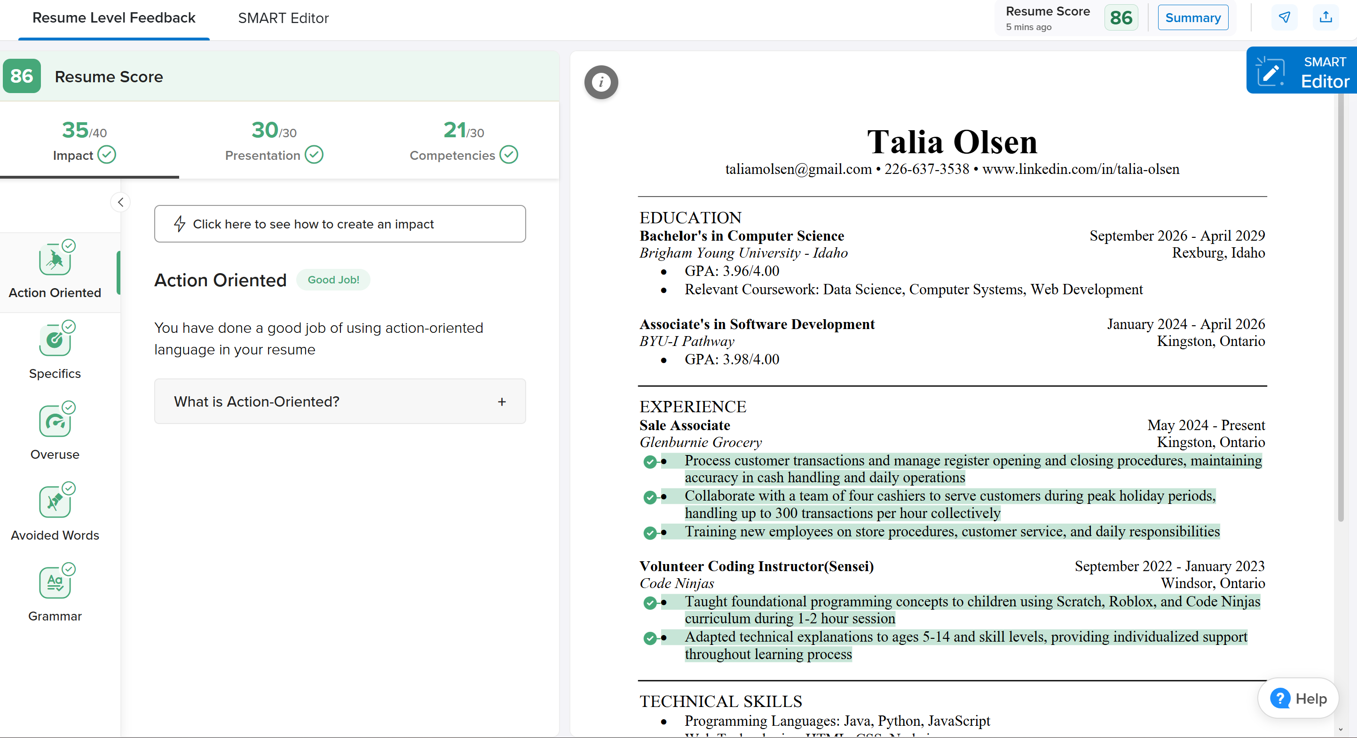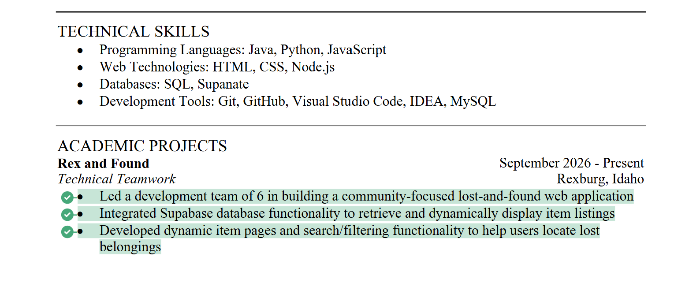

- Describe (2-3 sentences min) what changes you will make to your résumé to improve it.
  - I would like to add more specifics in my academic projects section, which will be easier once the project is finished and launched. I would like to add more points that reflect my leadership skills, like professional mentoring and youth development. I already have some things like that, but I need to figure out how to make them more specific to what VMock wants.

- After completing a VMock practice interview, what changes can you make to communicate more effectively?
  - My content strength needs some works, and I need to stop using filler words. I specifically paid attention to my facial expression, but still scored low so I need to also smile more. There were a few questions where I got a little overwhelmed and didn’t fully answer the question because I spent too long on the first part of it.
- Please provide a screenshot of your completed interview. See example below.


